Hands on Practice on Reconnaissance Tool theHarvester

Task #1 :

Verify the tool
Command:
theHarvester --version Screen Shot:
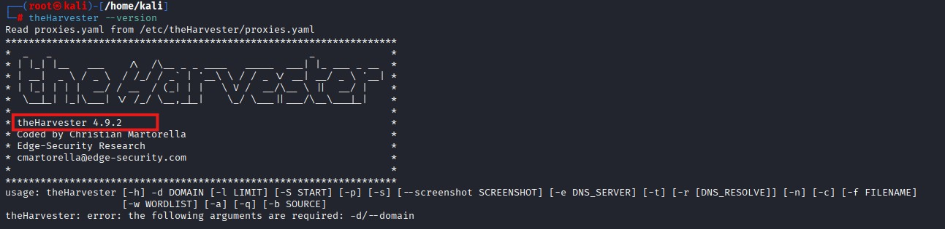
Explanation:
We can check the Version of the harvester if it is install it will show the current version of the harvester if it is not install then use (sudo apt install theHarvester –y) to install it.
Task#2:
Discover Subdomains from Certificate Logs
Command:
theHarvester -d eccouncil.org -l 100 -b crtsh

Screenshot:
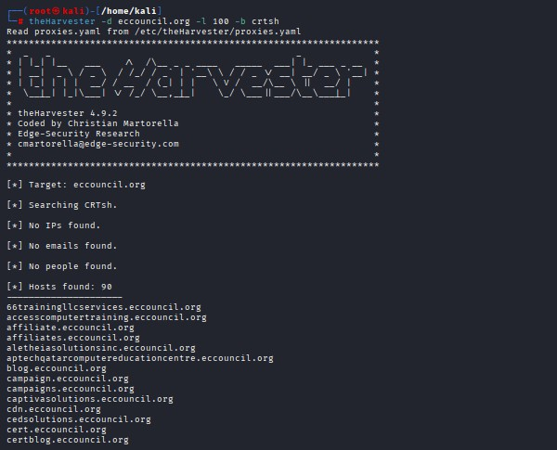
Explanation:
By using command of crtsh we can discover the subdomains of the target Task#3:
Gather Passive DNS Information
Command:
theHarvester -d eccouncil.org -l 50 -b rapiddns
Screenshot:
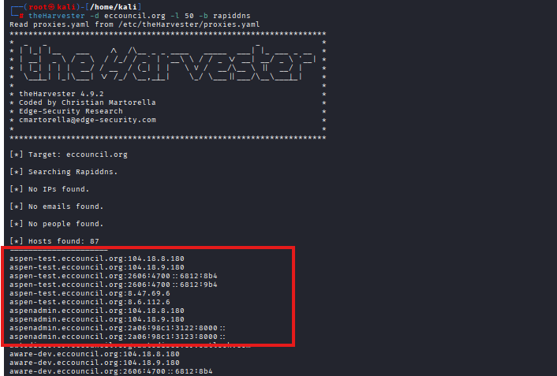
New Findings:
Comparing the result of task 3 with task 2 we manage to find the some new subdomains and Ip's as well.

aspen-test.eccouncil.org:104.18.8.180 aspentest.eccouncil.org:104.18.9.180 aspentest.eccouncil.org:2606:4700::6812:8b4 aspentest.eccouncil.org:2606:4700::6812:9b4 aspen-
test.eccouncil.org:8.47.69.6 aspen-test.eccouncil.org:8.6.112.6
aspenadmin.eccouncil.org:104.18.8.180 aspenadmin.eccouncil.org:104.18.9.180 aspenadmin.eccouncil.org:2a06:98c1:3122:8000:: aspenadmin.eccouncil.org:2a06:98c1:3123:8000::

Task#4:
Resolve Discovered Hosts to IP Addresses
Command:
theHarvester -d eccouncil.org -b crtsh -r
Screenshot:
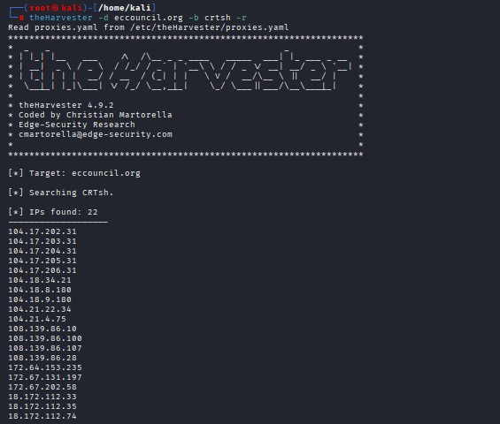
Explanation:
We have discovered some hosts along with their Ip addresses.

- connect.eccouncil.org → 104.17.202.31
- cdn.eccouncil.org → 108.139.86.10
- labs.eccouncil.org → 40.114.68.21
Task#5:
Export the Reconnaissance Report
Command:
theHarvester -d eccouncil.org -b crtsh -f eccouncil_report Screenshot:
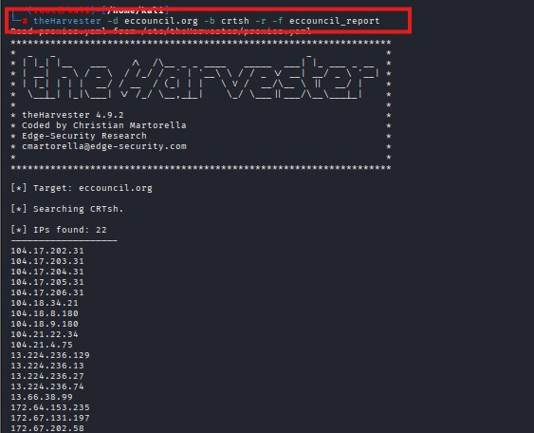
Explanation:
So by using –f command we can export all the subdomains and ips in just 1 Json file .

why passive reconnaissance is difficult to detect.
Passive reconnaissance is difficult to detect because it totally rely on the information available over the internet so attacker is not targeting any organization or individual just gather information over the internet and target remain unaware where someone is gathering information against them or not .

